School of Computer Science and Artificial Intelligence
Lab Assignment # 10.2

Program : B. Tech (CSE)
Specialization : -
Course Title : AI Assisted Coding
Course Code : 23CS002PC304
Semester : II
Academic Session : 2025-2026
Name of Student : Yeshwanth
Enrollment No. : 2403A51L39
Batch No : 51
Date : 10/02/26

Task -01(Error Detection and Correction)
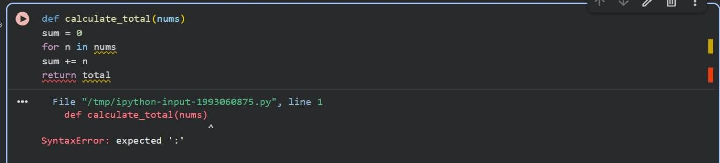
Code used:

Prompt: Correct the code and give brief explanations of the identified syntax and logic errors.

Output:
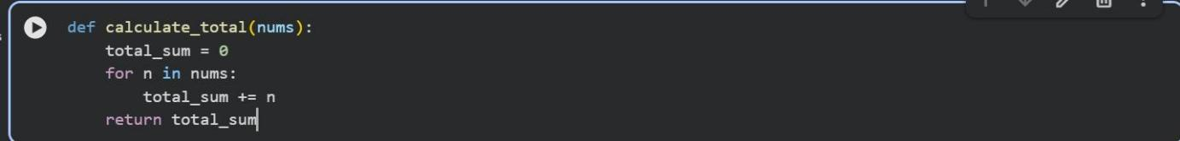
Explaination:

- Missing colons: Python requires a colon : at the end of def (function definition) and for (loop definition) statements.

- Variable shadowing: I renamed the sum variable to total_sum to avoid overwriting Python's built-in sum() function, which can lead to unexpected behavior.

- Undefined variable: The function was trying to return total, but the variable was named sum (or total_sum after the fix). I've corrected it to return total_sum.

Task-02(Code Style Standardization)
Code Used:

Prompt: convert the code to follow standard style conventions.

Output:
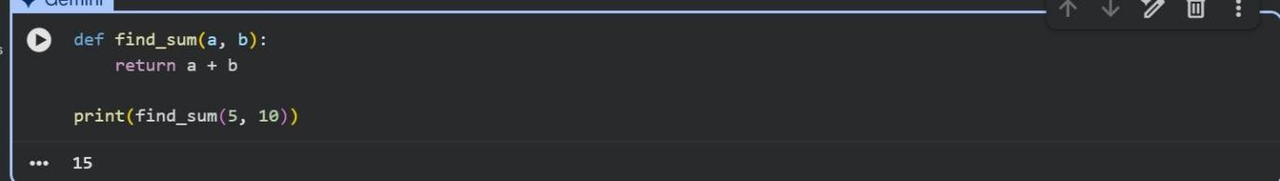

Task-03(Code Clarity Improvement)
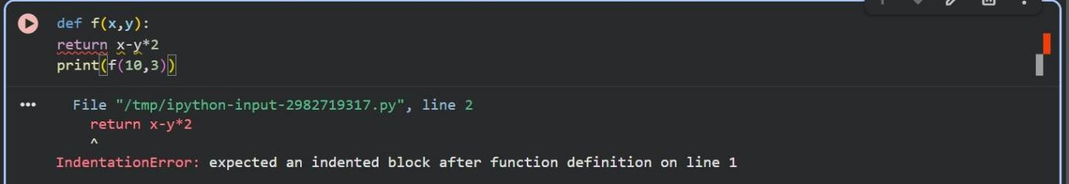
Code used:

Prompt: rewrite the code with meaningful function and variable names, proper indentation, and improved clarity.
Output:
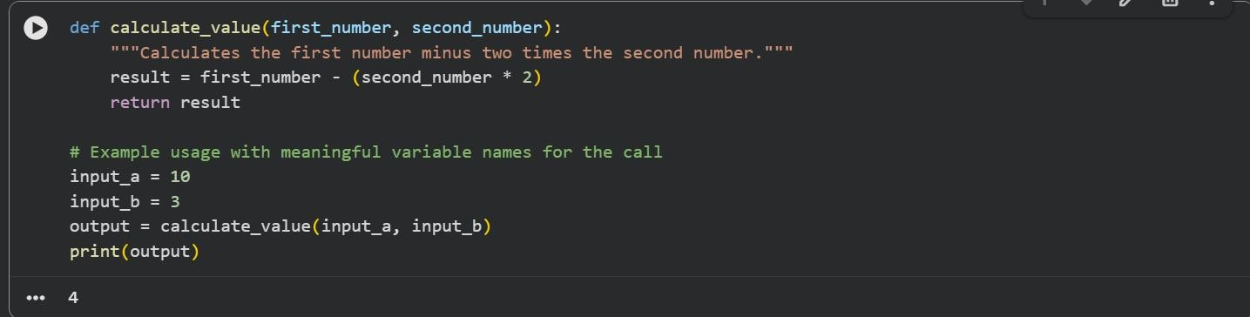

Task-04(Structural Refactoring)
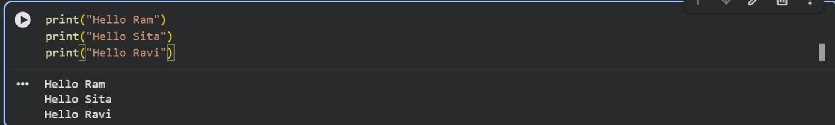
Code used:

Prompt:make the code modular using reusable functions to eliminate repetition.

Output:
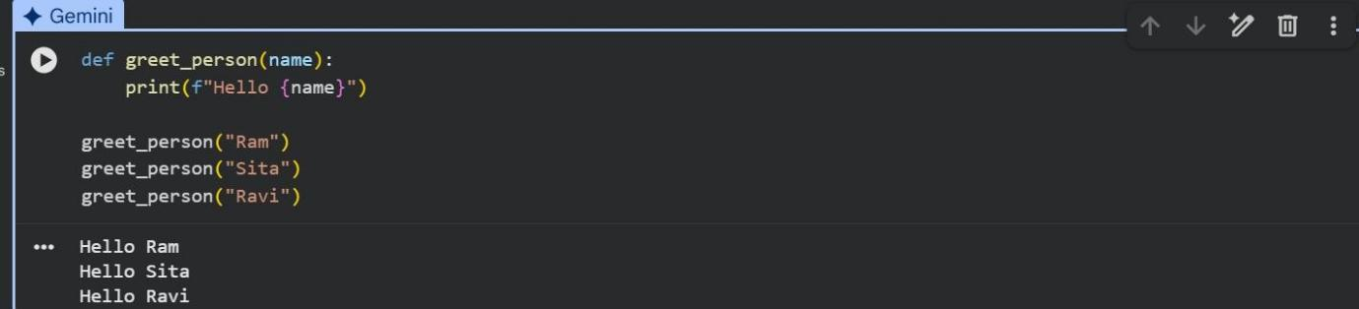

Task-05(Efficiency Enhancement)
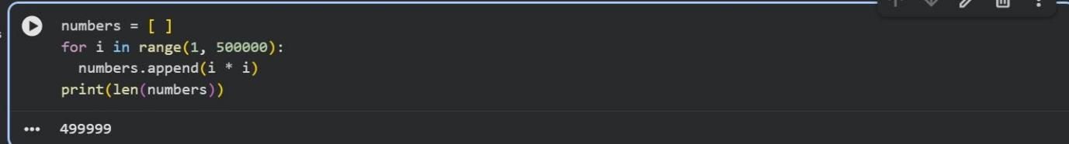
Code used:

Prompt: Optimize the code to achieve the same result with improved performance.

Output:
